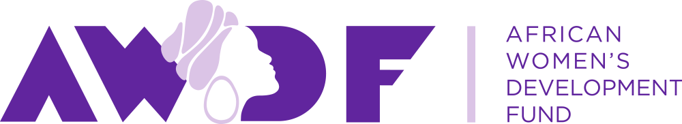

Job Vacancy

Consultant- Senior Advisor: The African Institute for Integrated Responses to Violence Against Women and Girls and HIV/AIDS (AIR)

Are you passionate about women’s rights in Africa, and embrace African women’s diversities?
Do you have experience of managing funding from governmental donor agencies?
Are you ready to contribute to building a cutting-edge grants portfolio advancing activism around African women’s bodily rights, economic justice, political voice and leadership?

Background

The African Women’s Development Fund (AWDF) is a pioneering grant making foundation headquartered in Ghana. AWDF was founded by and for African women. Since 2001 we have awarded over 26 million USD in grants to support leading women’s rights organisations and feminist movements across Africa.

Nature of Services: Senior Advisor - AIR

Summary of Services

Leads on the direction, management and implementation of AIR- the African Institute for Integrated Responses to Violence Against Women and Girls and HIV/AIDS, reporting to the Director of Programmes.

About AIR:

AIR has been incubated by the Stephen Lewis Foundation since 2008 and developed with advisory input from African practitioner-activists. In 2017 an agreement was reached to host AIR at AWDF, while the nature of its future format is designed and implemented. The core idea of AIR is to create a network of African-based, women-centered/feminist technical support on the issues of violence against women, HIV/AIDS and mental and emotional health and wellbeing. AIR will not run services itself, but rather support creative yet practical thinking on the best ways to respond.

About the role:

The Consultant will guide the process of launching AIR as a fully-fledged initiative, including through development of AIR’s programming, external communications and external profile; and governance and administrative considerations involved in hosting it as an initiative of AWDF or alternative administrative structure, as developed by the consultant in consultation with AWDF and AIR stakeholders, including the former AIR Steering Committee, in keeping with AIR’s collaborative spirit and practitioner-driven vision.

In this role, the Consultant works closely with AWDF’s senior management team, reporting to the Director of Programmes. There will be a close working relationship with members of AWDF programme staff, including the Grants department, the Communications team and the Knowledge Management Specialist. The Consultant will also work with external contractors such as web developers, graphic designers and potential donors, as required.

Location

Home-based to start, with travel as required

Specific responsibilities
Programme direction

- Lead on the development of AIR’s strategic direction and programme plan
- Oversee and develop implementation of AIR programming, initially in relation to the two methodological tools developed to date. This includes field testing, consultation and facilitating use of the tools.
- Guide strategic decision making around AIR governance, including leading on the development of thinking as to the nature of entity AIR should become.
- Provide thought-leadership in profiling AIR’s conceptual contributions and frameworks including through writing, presentations in public fora and other analysis of AIR’s work for external audiences, and identifying spaces for AIR partners and programming to be profiled
- Liaise between AIR and its stakeholders, including the Stephen Lewis Foundation.
- Oversee development and implementation of a Learning (Monitoring and Evaluation) framework for AIR
- Act as an external-facing representative for AIR, including as a speaker and contributor in relevant forums

Programme management

- Ensure timely and quality delivery of AIR programming outputs
- Liaise with AWDF (programmes and finance) in management of AIR budget and programme resources
- Identify new funding opportunities, develop applications when appropriate (with support and collaboration as needed), and provide input into funding proposals and reports prepared by AWDF.
- Identify and/or liaise with external contractors (e.g. designers, substantive consultants) as needed for planning and implementing AIR activities.
- Act as the key point of contact with AIR external stakeholders
- Lead on conceptual and content development of AIR website in collaboration with external contractors and ensure AIR website is updated

Other

Participate in broader AWDF events and initiatives as appropriate

Qualifications:

- At least 10 years of experience in managing and implementing women’s rights programming in the African region and/or in relation to AIR’s focal areas
- Background in and expert knowledge of women’s rights, HIV/AIDS and development, humanitarian and/or human rights interventions in the African region and in relation to AIR’s core program areas of psycho social recovery
- Strong project management skills, including strong attention to detail
- Strong interpersonal skills and a desire to contribute to a positive, collaborative work environment
- Personal commitment to the values of solidarity, mutual respect, collaboration, inclusiveness, and social justice as embodied in AWDF’s values and articulated in the African Feminist Charter
- Strong computer skills, including excel, databases, word processing, presentation packages (Power Point), internet, and email
- High level of personal initiative/proactiveness
- Strong understanding of and commitment to women’s rights in Africa
- Excellent ability to communicate with warmth, professionalism, clarity and tact via written and verbal mediums
- Comfort with a fast-paced work environment that requires flexibility and multi-tasking

Qualified and interested candidates should send a written application (1 page) and a CV of not more than 3 pages to the Human Resources Manager, African Women’s Development Fund (AWDF) by email to grace@awdf.org indicating ‘Consultant (Senior Advisor, AIR)’. Physical address is:

AWDF House, Justice Sarkodie Avenue,
Plot no. 78 Ambassadorial Enclave,
East Legon, Accra.

Postal address: P.M.B CT 89, Cantonments Accra, Ghana.

Applications should reach the HR not later than May 26, 2017. Only shortlisted candidates will be contacted for additional information and interviews.

